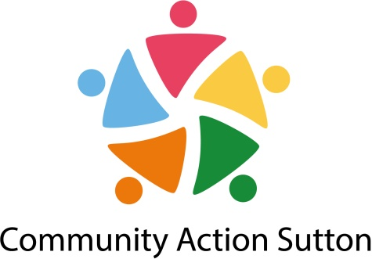

**JOB DESCRIPTION**

**JOB TITLE:** Sessional Worker

**RESPONSIBLE TO:** Head of Partnerships Impact and Equality

**GRADE:** N/A

**SALARY:** £15 per hour

**HOURS:** 4 hours per month (this is evening)

**CONTRACT:** Fixed-term until 31 March 2023 (Post subject to further funding)

**__________________________________________________________________________**

**Purpose of the Post**

To assist in the delivery of the Men in Sheds Programme.

Sutton Men in Sheds provides a community space/place for men to connect, engage in conversation, create and pursue practical interest. The project engages vulnerable men dealing with mental health issues and will develop a referral system where relevant referrals will be made once specific need for further support are identified. The overall aim of the project for men is:

* Suicide prevention
* Support in emotional well-being.
* Support men struggling with relationship breakdown or access to their children
* Reduce loneliness and isolation
* Provide access to debt management
* Provide a forum to have meaningful conversation
* A support group/network
* Sharing skill and knowledge
* Engage men from disadvantage groups

**___________________________________________________________________________**

**Main Responsibilities:**

1. To oversee the development of the Men in Sheds Programme, and generic activities that are responsive to local needs, including:
   1. Two Men in Sheds sessions led by local men, Mentoring for Self Confidence/Leadership, Indoor and Outdoor activities , Healthy Lifestyle and Living and signpost men to access information, advice and guidance.
2. To engage with men from the local community and to listen to, support and to advocate on their behalf.
3. To provide the content to the Head of Partnerships, Impact and Equality to then co-ordinate and present relevant publicity materials including regular twitter posts (With support from the centre manager).
4. To report to line manager and any other reports, evaluations, surveys, etc.
5. Have a sound understanding of issues affecting men safeguarding issues and act appropriately should issues of concern arise and follow the policies and procedures for the effective operation of the sessions. Please note support/training will be given if needed.
6. Maintain in confidentiality in all aspects of your work, attend training when required for example Safeguarding and First Aid (training will be paid).
7. Receive and participate in supervision and training as deemed necessary and in line with Community Action Sutton policies.
8. Operate within and promote Community Action Sutton policies in areas of equal opportunities, health and safety and customer care.