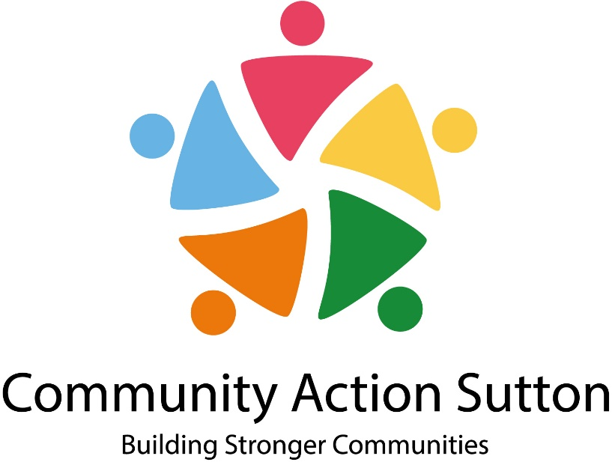

Job Pack

Executive Support Manager

This pack contains the following:

- About Community Action Sutton
- How to apply
- Role description and person specification





Granfers Community Centre, 73-79 Oakhill Road, Sutton Surrey, SM1 3AA
020 8644 2867
enquiries@communityactionsutton.org.uk
@ComActionSutton
@CommunityActionSutton

About Community Action Sutton

As the local infrastructure organisation, we support, develop and promote the voluntary, community and social enterprise sector in the London Borough of Sutton. We provide information, advice & guidance and support groups with a range of issues including capacity building, governance, finance and fundraising. We also provide number of services, including admin support, training and consultancy, a complete payroll service and community accountancy.

We have almost 300 voluntary and community groups in our membership. These vary considerably in size and scope ranging from small volunteer led community groups to large organisations employing larger cohorts of staff and providing services to significant numbers of local people.

We have many projects on the go at any one time as well as running our popular training courses and networking events. We co-ordinate and facilitate many different forums for the voluntary sector in Sutton. To ensure the sector is kept up to date with relevant news and information both locally and nationally we send out regular information via e-bulletins and through our social media platforms.

Our Vision
Promote equality and diversity and positive change for communities in the Borough of Sutton.

Our Mission
To LEAD and Act as a CATALYST in the advancement of the VCSE Sector as a strategic partner and deliverer of services in Sutton.

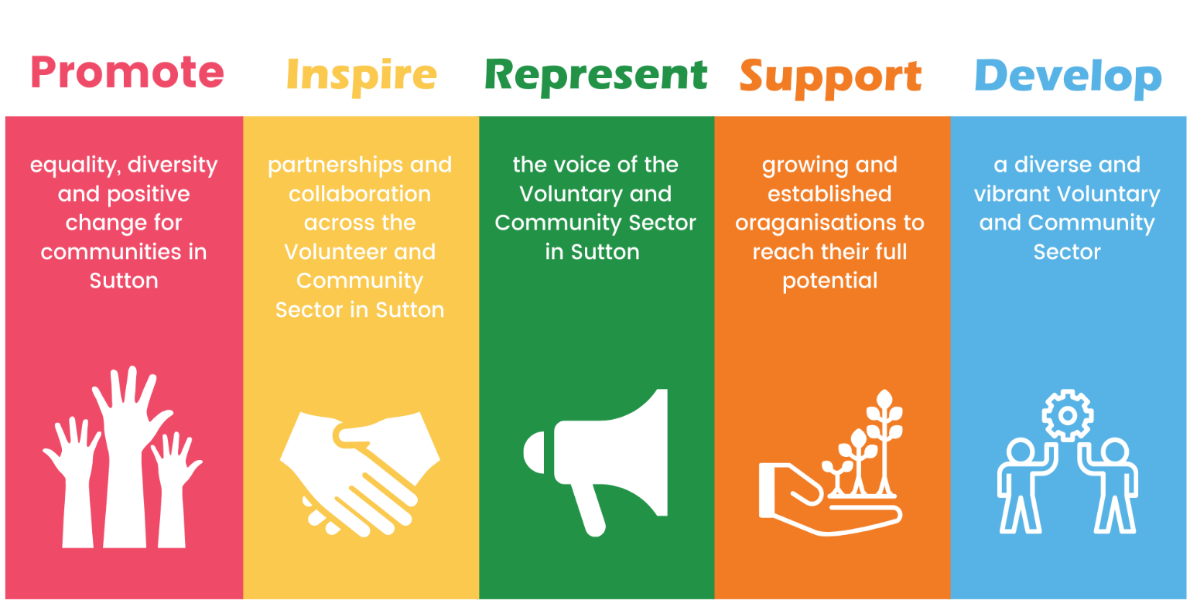

We are a small charity with 16 staff, based at Granfers Community Centre, 73-79 Oakhill Road, Sutton, SM1 3AA. Staff Currently work via a hybrid arrangement, part from home, part from the office.

Community Action Sutton enjoys an open, flexible and energetic working environment, we support our staff to grow and develop both personally and professionally.

We all contribute and work to our core values to ensure the charity’s vision to promote equality & diversity and positive change for communities in Sutton is at the forefront of everything we do. We have built excellent working relationships with our key stakeholders and partners and work closely with the local authority.

How to apply

To apply for this post you must complete a Community Action Sutton application form.
We encourage all applicants to read through the guidance notes below before completing the application form.

Selection for interview will depend solely on the information contained in your application form.

Person Specification
The person specification enables us to recruit the best person for the job as it outlines the abilities, skills, knowledge and experience necessary to carry out the job.

Please read it carefully and address your application to the criteria mentioned in it.

Your selection for interview will depend on this.

Please fill in your form to show how you match the requirements.

Relevant Skills and Experience
There is no need to include a CV or repeat your work history.

Pick out those aspects of your experience or skills that are relevant to this job and explain how your ability, skills and knowledge match those required in the person specification.

Remember to consider experience in previous work and relevant experience outside of paid work such as gained at home, in the community or through voluntary/leisure/ college activities.

Give examples where you can in support of your application.

Where length of experience is specified, make sure you give correct dates as this information will be needed to check you meet the experience requirements.

Ensure you refer to all items on the person specification, whether you already work for the organisation or not.

If you need help in completing the application form, please contact us.

Feedback
Community Action Sutton is keen to ensure equality of opportunity in its recruitment and selection process.

If you wish to discuss why you were not selected after interview, please contact this office and we will be pleased to give you feedback.

Completed application forms should be emailed to;
enquiries@communityactionsutton.org.uk

Your application form must reach us by the closing date. Applications received after this date will not be considered.

Key Dates

Closing date for applications: 12noon on Monday 16th March 2026

Interviews will be held: Week Commencing 23rd March 2026

Next Steps

If you are selected for interview, we will contact you by email confirming the details. If you have not heard from us within 2 weeks of the closing date, please assume that, on this occasion, your application has been unsuccessful.

The Role

Job Description

Position: Executive Support Manager
Hours: 21 per week
Salary: £38,000 to £43,500 pa FTE – (£22,800 to £26,100 pa pro-rata)
Reporting to: Chief Executive
Contract Type: Permanent
Responsible for: Admin Support Staff, Apprentices and Volunteers

Purpose of the Post
- To manage all aspects of the Community Action Sutton office.
- To provide strategic advice and input to the organisational objectives.
- Point of contact when CEO is unavailable.
- To provide policy development and HR support to the CEO.
- To provide executive support to the CEO in relation to voluntary and community sector leaderships, strategic networks/forums and meetings
- To proactively support the CEO on all aspects of the organisation’s running, including governance, HR, internal culture, the Trustee Board and external strategy.
- To provide support to the team around project development and delivery, as necessary

Management of Community Action Sutton Office
- Oversee the process of how all general enquiries to Community Action Sutton are dealt with.
- Oversee all the admin services ensuring these are effective and appropriate.
- Take responsibility for all premises issues (including health and safety) and liaise with the Centre Manager as necessary, including the cleaning contract.
- Manage (with support from the Chief Executive) the contracts for the office. systems, reviewing them on an annual basis to ensure the best value for money.

Policy Development and HR
- To oversee and manage the regular reviewing and updating of Community Action Sutton policy frameworks
- To ensure that personnel paperwork is up to date and use Brighthr to its full potential.

Governance
- To support the Chief Executive in all aspects of organisational governance and offer tactical advice as appropriate, including Board meetings and the AGM.

Community and voluntary sector leadership, strategic networks/forums and meetings
- To support the CEO in the planning and delivery of strategic networks/forums and meetings, including the scheduling of meetings, production of agendas/minutes and follow up actions.

Community Action Sutton Projects
- To provide internal leadership to ensure the delivery on projects.
- To support reporting and data management activity within the organisation

General:
- Ensure admin support is provided for the Chief Executive and Chair as required.
- To support income generation activity
• To be an active member of the Community Action Sutton Staff Team, attend all relevant meetings and provide smooth communication between teams.
• Receive and participate in supervision and training as deemed necessary and in line with Community Action Sutton policies.
• Operate within and promote Community Action Sutton policies in areas of equal opportunities, Health and Safety and customer care.

Person Specification

Knowledge and Experience

Essential
- Similar experience supporting a CEO, Executive Director, or senior leadership team.
- Strong understanding of governance processes, such as Board and committee support.
- Experience managing diaries, complex scheduling, and confidential correspondence.
- Experience preparing reports, minutes, and board papers.
- Experience handling sensitive information with discretion and professionalism.
- Experience improving administrative systems and processes.
- Experience of line management
- Experience of dealing with HR issues

Desirable
- Knowledge of charity governance and regulatory frameworks.
- Knowledge and experience of charity, community or faith sector
- Experience working in a charity or relevant public sector or social purpose organisation
- Experience supporting trustees or non-executive boards.
- Experience managing small administrative teams or volunteers.

Personal abilities

- Strong commitment to the charity’s mission and values.
- Ability to use own initiative
- An adaptable and flexible approach to workload
- High levels of accuracy and attention to detail
- Ability to work flexible hours i.e. weekends and evenings
- Understanding of and willingness to work within an Equal Opportunities Framework
- Excellent organisational skills
- Excellent communication skills (written and oral) and interpersonal skills
- Leadership skills

