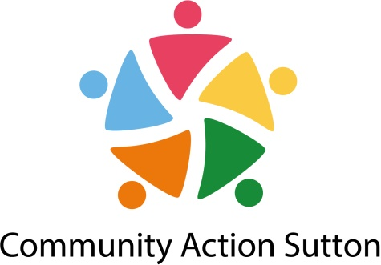

JOB DESCRIPTION
JOB TITLE: Community Development Officer
RESPONSIBLE TO: Head of Partnerships Impact and Equality
GRADE: PO3, Scale Point 35
SALARY: £30,785 - £34,000 pa
HOURS: 35 hours per week including some unsociable hours (there will be some evening and weekend work for which time off in lieu will be given)
CONTRACT: Fixed-term until 31 March 2023 (Post subject to further funding)
___________________________________________________________________________
Purpose of the Post
To manage the organisations community development work, with a focus on supporting small community groups and groups working with marginalised communities in Sutton to start new projects and to attract new funding.
___________________________________________________________________________
Main Responsibilities
Community Development
- To identify communities of geography and of identity (including health inequalities, BAME, Faith, Disability and LGBT) and work with them to develop asset based approaches to responding to community need
- To take use asset based approach when working with communities.
- To support local community projects as identified through work with community members

Funding
- To identify funding opportunities (especially outside of borough) to encourage and support groups to apply successfully. (at least 50% of our current membership)
- To use and promote the Grantfinder system.

Organisational Development
- To deliver organisational development support, including one to one work, training, events, workshops, to community groups.
- To provide one to one support to community groups on a range of organisational development and management issues, including developing constitutions, legal structures, business planning, fundraising and signposting to specialist services as required.
- To carry out organisational development checks to provide a baseline for Community Action Sutton development work, supporting the follow up actions/plans, and signposting to other Community Action Sutton staff or specialist services for specific support as appropriate.
- To support community groups to achieve organisational quality standards, where appropriate.
- To produce learning and development materials.
- To contribute to the development and delivery of a programme of learning for voluntary and community sector organisations in Sutton.
- To facilitate forums and networks

General
- Ensure good practice in all development work, and ensure all delivery is effectively monitored in order to demonstrate impact.
- Promote the delivery of Community Action Sutton services and training to generate income.
- Be an active member of the Community Action Sutton Staff Team and attend all relevant meetings.
- Receive and participate in supervision and training as deemed necessary and in line with Community Action Sutton policies.
- Operate within and promote Community Action Sutton policies in areas of equal opportunities, health and safety and customer care.

PERSON SPECIFICATION

Knowledge/Abilities

- Knowledge, understanding, and commitment to the process of community development
- Knowledge and understanding of setting up and running small organisations including developing a constitution, developing strategy, committee members’ roles and responsibilities, development of policies and practices and running the day to day operation
- Experience of searching for different funding sources and writing funding bids.
- Knowledge of the legislative requirements that impact on VCS groups and in particular the role and requirements of the Charity Commission
- Ability to communicate clearly and liaise with people at different organisational levels and from a variety of backgrounds
- Ability to work in a facilitative way with community members and small groups which enables them to identify, analyse and meet community and organisational needs

Personal abilities

- Ability and commitment to team work
- Ability to take, and work on own, initiative
- Ability to be self-servicing and use office equipment, including IT skills in Word and Excel
- Ability to work flexible hours i.e. weekends and evenings
- Understanding of and willingness to work within an Equal Opportunities Framework

Experience/Qualifications

- Experience of supporting individual community members to become community activists
- Experience/knowledge of working with inequality / marginalized groups
- Experience of working with community/grassroots groups
- Experience of developing and delivering learning programmes
- Experience of supporting partnerships/network and forums
- Experience of monitoring and evaluation frameworks

