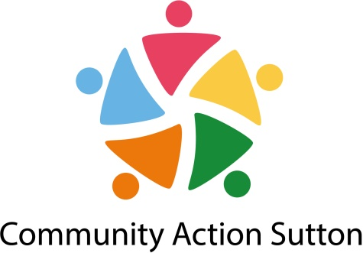

**JOB DESCRIPTION**

**JOB TITLE:** CommunityDevelopment Officer

**RESPONSIBLE TO:** Head of Partnerships Impact and Equality

**GRADE:** PO3, Scale Point 35

**SALARY:** £30,785 - £34,000 pa

**HOURS:** 35 hours per week including some unsociable hours (there will be some evening and weekend work for which time off in lieu will be given)

**CONTRACT:** Fixed-term until 31 March 2023 (Post subject to further funding)

**___________________________________________________________________________**

**Purpose of the Post**

To manage the organisations community development work, with a focus on supporting small community groups and groups working with marginalised communities in Sutton to start new projects and to attract new funding.

**___________________________________________________________________________**

**Main Responsibilities**

**Community Development**

1. To identify communities of geography and of identity (including health inequalities, BAME, Faith, Disability and LGBT) and work with them to develop asset based approaches to responding to community need
2. To take use asset based approach when working with communities.
3. To support local community projects as identified through work with community members

**Funding**

1. To identify funding opportunities (especially outside of borough) to encourage and support groups to apply successfully. (at least 50% of our current membership)
2. To use and promote the Grantfinder system.

**Organisational Development**

1. To deliver organisational development support, including one to one work, training, events, workshops, to community groups.
2. To provide one to one support to community groups on a range of organisational development and management issues, including developing constitutions, legal structures, business planning, fundraising and signposting to specialist services as required.
3. To carry out organisational development checks to provide a baseline for Community Action Sutton development work, supporting the follow up actions/plans, and signposting to other Community Action Sutton staff or specialist services for specific support as appropriate.
4. To support community groups to achieve organisational quality standards, where appropriate.
5. To produce learning and development materials.
6. To contribute to the development and delivery of a programme of learning for voluntary and community sector organisations in Sutton.
7. To facilitate forums and networks

**General**

1. Ensure good practice in all development work, and ensure all delivery is effectively monitored in order to demonstrate impact.
2. Promote the delivery of Community Action Sutton services and training to generate income.
3. Be an active member of the Community Action Sutton Staff Team and attend all relevant meetings.
4. Receive and participate in supervision and training as deemed necessary and in line with Community Action Sutton policies.
5. Operate within and promote Community Action Sutton policies in areas of equal opportunities, health and safety and customer care.



**PERSON SPECIFICATION**

**Knowledge/Abilities**

1. Knowledge, understanding, and commitment to the process of community development
2. Knowledge and understanding of setting up and running small organisations including developing a constitution, developing strategy, committee members’ roles and responsibilities, development of policies and practices and running the day to day operation
3. Experience of searching for different funding sources and writing funding bids.
4. Knowledge of the legislative requirements that impact on VCS groups and in particular the role and requirements of the Charity Commission
5. Ability to communicate clearly and liaise with people at different organisational levels and from a variety of backgrounds
6. Ability to work in a facilitative way with community members and small groups which enables them to identify, analyse and meet community and organisational needs

**Personal abilities**

1. Ability and commitment to team work
2. Ability to take, and work on own, initiative
3. Ability to be self-servicing and use office equipment, including IT skills in Word and Excel
4. Ability to work flexible hours i.e. weekends and evenings
5. Understanding of and willingness to work within an Equal Opportunities Framework

**Experience/Qualifications**

1. Experience of supporting individual community members to become community activists
2. Experience/knowledge of working with inequality / marginalized groups
3. Experience of working with community/grassroots groups
4. Experience of developing and delivering learning programmes
5. Experience of supporting partnerships/network and forums
6. Experience of monitoring and evaluation frameworks